LAB 4
Write Python code to implement the following. Consider dataset file as “HR_comma_sep.csv”
1. Do some exploratory data analysis to figure out which variables have direct and clear impact on employee retention (i.e. whether they leave the company or continue to work)
2. Plot bar charts showing impact of employee salaries on retention
3. Plot bar charts showing corelation between department and employee retention
4. Build logistic regression model using variables that were narrowed down in step 1
5. Measure the accuracy of the model

import pandas as pd
import matplotlib.pyplot as plt
import seaborn as sns

from sklearn.model_selection import train_test_split
from sklearn.linear_model import LogisticRegression
from sklearn.metrics import accuracy_score, confusion_matrix

hr = pd.read_csv("HR_comma_sep.csv")

print("First 5 Rows:")
print(hr.head())

plt.figure(figsize=(10,6))
sns.heatmap(
hr.select_dtypes(include=['int64','float64']).corr(),
annot=True,
cmap="coolwarm"
)
plt.title("Correlation Matrix")
plt.show()

pd.crosstab(hr.salary, hr.left).plot(kind='bar')
plt.title("Salary vs Employee Retention")
plt.xlabel("Salary")
plt.ylabel("Number of Employees")
plt.show()

pd.crosstab(hr.Department, hr.left).plot(kind='bar', figsize=(10,6))
plt.title("Department vs Employee Retention")
plt.xlabel("Department")
plt.ylabel("Number of Employees")
plt.show()

hr = pd.get_dummies(hr, columns=['salary','Department'], drop_first=True)

X = hr.drop("left", axis=1)
y = hr["left"]

X_train, X_test, y_train, y_test = train_test_split(
X, y, test_size=0.3, random_state=42)

model = LogisticRegression(max_iter=1000)
model.fit(X_train, y_train)

y_pred = model.predict(X_test)
accuracy = accuracy_score(y_test, y_pred)
print("Binary Classification Accuracy:", accuracy)
cm = confusion_matrix(y_test, y_pred)

plt.figure(figsize=(5,4))
sns.heatmap(cm, annot=True, fmt='d')
plt.title("Confusion Matrix - Binary")
plt.xlabel("Predicted")
plt.ylabel("Actual")
plt.show()

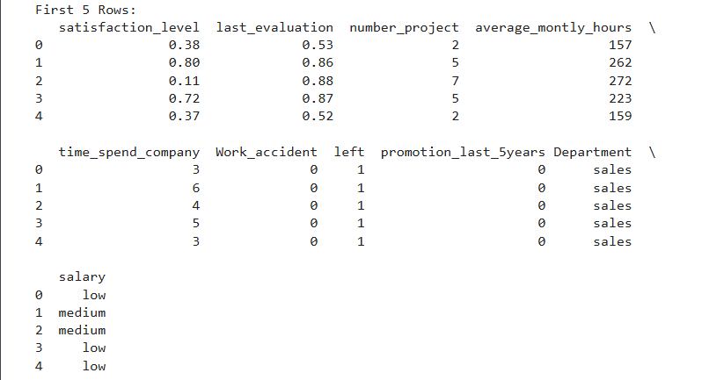

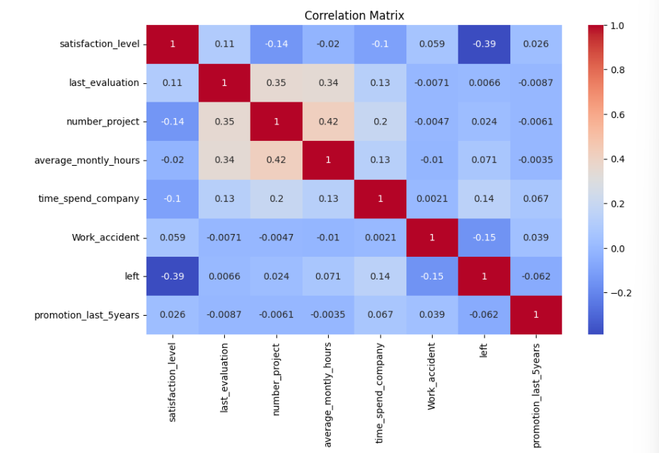

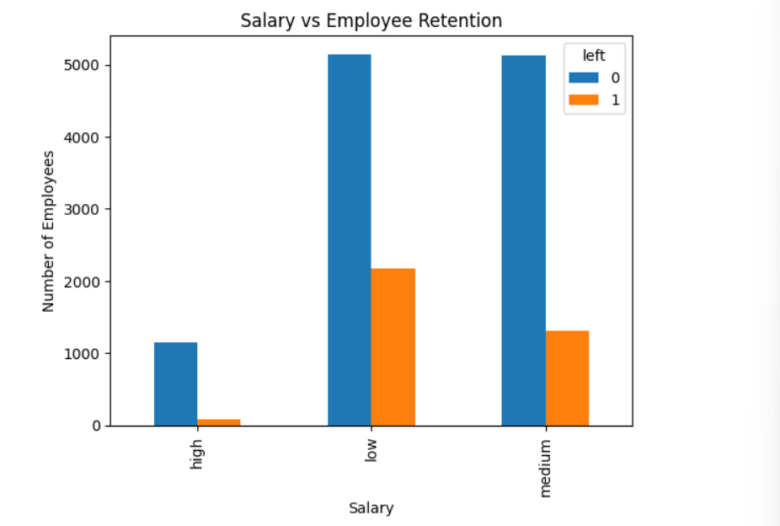

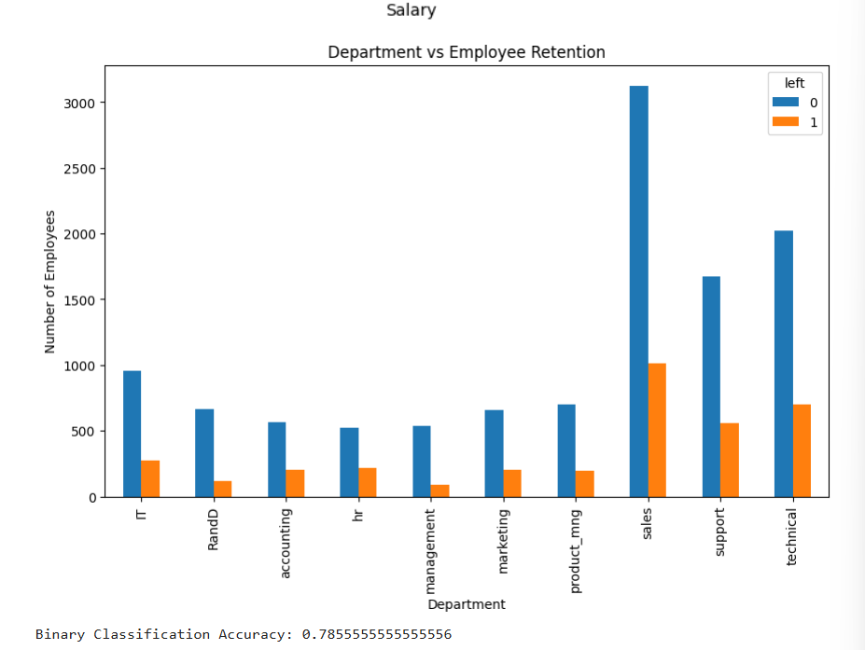

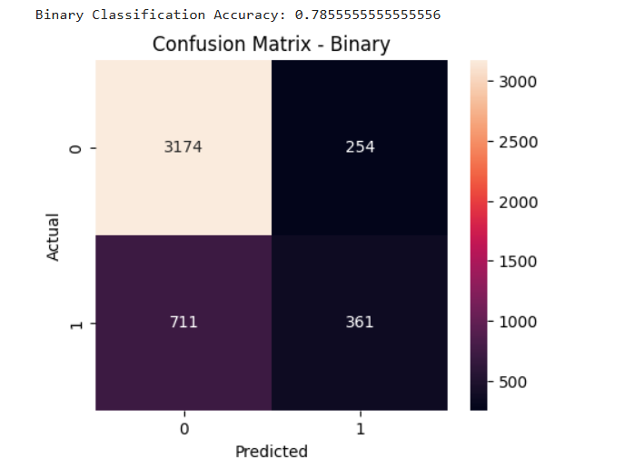

Write Python code to implement the following. Consider dataset file “zoo-data.csv” to predict. Details of class type is provided in “zoo-class_type .csv”
1. If require apply necessary data preprocessing.
2. Build logistic regression model to predict “class_type”
3. Measure the accuracy of the model
4. Plot the confusion matrix

import pandas as pd
import matplotlib.pyplot as plt
import seaborn as sns

from sklearn.model_selection import train_test_split
from sklearn.linear_model import LogisticRegression
from sklearn.metrics import accuracy_score, confusion_matrix

zoo = pd.read_csv("zoo-data.csv")
print("First 5 Rows:")
print(zoo.head())
zoo = zoo.drop("animal_name", axis=1)
X = zoo.drop("class_type", axis=1)
y = zoo["class_type"]

X_train, X_test, y_train, y_test = train_test_split(
X, y, test_size=0.3, random_state=42)

model = LogisticRegression(max_iter=1000, multi_class='multinomial')
model.fit(X_train, y_train)

y_pred = model.predict(X_test)

print("Multiclass Classification Accuracy:",
accuracy_score(y_test, y_pred))

cm = confusion_matrix(y_test, y_pred)

plt.figure(figsize=(6,5))
sns.heatmap(cm, annot=True, fmt='d')
plt.title("Confusion Matrix - Multiclass")
plt.xlabel("Predicted")
plt.ylabel("Actual")
plt.show()

